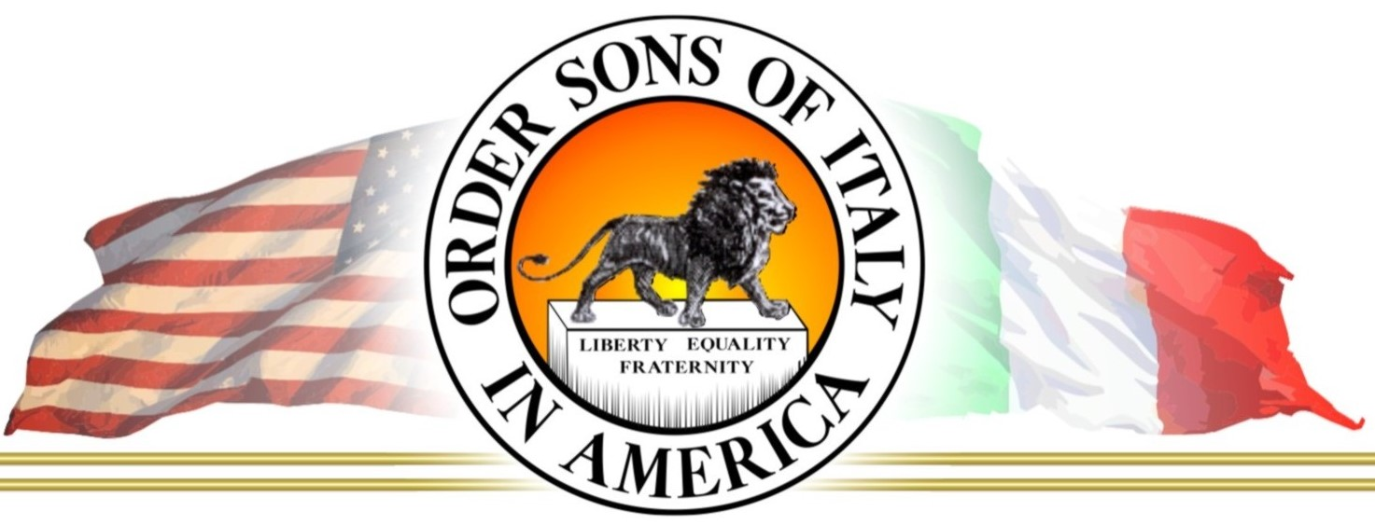

OSIA/OSDIA
Order Sons of Italy in America

- Local lodges have approximately 14 to 17 officers elected by the general membership that lead the lodge meetings

- Both men and women can join OSIA and participate fully and equally. Nationally, of the 34,000 members, 50% are women, 50% are men.

- Lodges meet monthly and the board of officers meets monthly in addition to the general meeting

- Members will be selected for or can volunteer for committees such as Bylaws, Activities, Charity, Fundraising, Membership, and Budget

- Annual dues average ($60 per year for most lodges in Colorado) can be set and changed by the lodge members as needed, depending on budget requirements

- General membership qualification for new members starting a lodge is based on the National Bylaws and reads as follows:

“Regular Members” are those members who are of Italian birth or descent: also, the spouses of those of Italian lineage, or those adopted by a person or persons of Italian lineage, and the spouses of such adopted persons; widows, widowers and divorced spouses of current or former members.

- All members receive a national publication titled “Italian America” magazine, a quarterly, full color publication (check the website below for info on the magazine).

- Members have full access to the “Members Only” section of the national website, www.osia.org

For information on joining or starting a lodge, contact:

Dan Onofrio 203-499-9187
Mark DeNunzio 850-932-8628

